A Case Study for Urban Stress Level Monitoring 18 March 2016

Varin Buff

Danielle Griego

Eric Hayoz

Introduction

With the emergence of cities as the predominant living & working environment it is important to further understand how people feel in such urban metropolises. However, perception and experienced stress levels are challenging metrics to measure and are even more difficult to correlate with an underlying causal-effectual relationship in such stimulus abundant environments. We can start analyzing this dynamic with the emergence of mobile sensing equipment and data science techniques. Therefore the aim of this study is to develop a quantitative methodology to indicate the predominant features that influence inhabitant’s perception in the urban context through the use of mobile sensing devices.

Research Question and Hypothesis

The goal of this study is to find an effective method to analyze heterogeneous data sources from select mobile sensing devices (Table 1 of the Appendix) to better understand the predominant factors, which influence perceptual qualities of inhabitants in the urban environment. Based previous behavioral studies utilizing biofeedback wearable devices, it is hypothesized that the change of state conditions such as light to dark, quiet to noisy, and/or low occupancy to high occupancy will have the greatest impact on stress levels. The research questions can be outlined in stages:

1. Do environmental factors such as temperature, noise, dust, illuminance and occupant density actually influence the stress levels of urban inhabitants?
2. Do responses only occur at expected change of state stimuli or are there other un-measured features that contribute to stress levels?
3. Do all (or most) urban dwellers respond similarly to the above stimuli?
4. Which of these externalities have the greatest contribution to measured stress levels?

Approach and Method

The hypothesis and research questions will be addressed by collecting and analysing data from an experimental set up where 25-40 participants will take the mobile sensing equipment along the same path (Figure 1). The path was chosen in such a way to show a variation in sound, occupancy density, light levels, traffic, etc. We will collect the data during a 2-week period during mid April. For the study, all study participants will make an initial calibration to establish a baseline for the biofeedback wristband by reading a 3-minute bedtime story to obtain their personal low stress level frequency. Next, participants will walk along the given path still wearing the biofeedback wristband, carrying the mobile sensors (all arranged in a “sensor-rucksack”). The given path is approximately 20 minutes and the participants will also be given a cue to respond to a mobile app if they find each section pleasant, unpleasant or neutral. This is important to understand the association with the biofeedback measurements since it only provides arousal levels and cannot be used to determine if it is positive, negative, or neutral.

Given the above experimental set up, the focus of this research project will be to develop an efficient workflow and appropriate data analysis techniques to answer our above research questions. Therefore the first step is to perform a pre-study to collect a sample data set, of which we will need to pre-process the data to reduce the noise of the environmental sensors and to align the heterogeneous sensor data to a common frequency. The biofeedback wristband data has the highest sampling frequency and will therefore be used as the reference for matching change of state events from the other sensors. We will also use this sample set to test different data analysis techniques to find correlations between the biofeedback data and the sensor measurements. The final stage will be to analyze the full set of data with the full experimental data set.

Contribution and expected outcomes

The findings of this project are not only important to understand the perceptual qualities of cities experienced by it’s inhabitants, but also to further utilize what is becoming ubiquitous mobile sensing devices. This experiment enables us to develop a workflow that others could use and further elaborate upon in future projects and potentially for the use of other citizen science projects.

Appendix

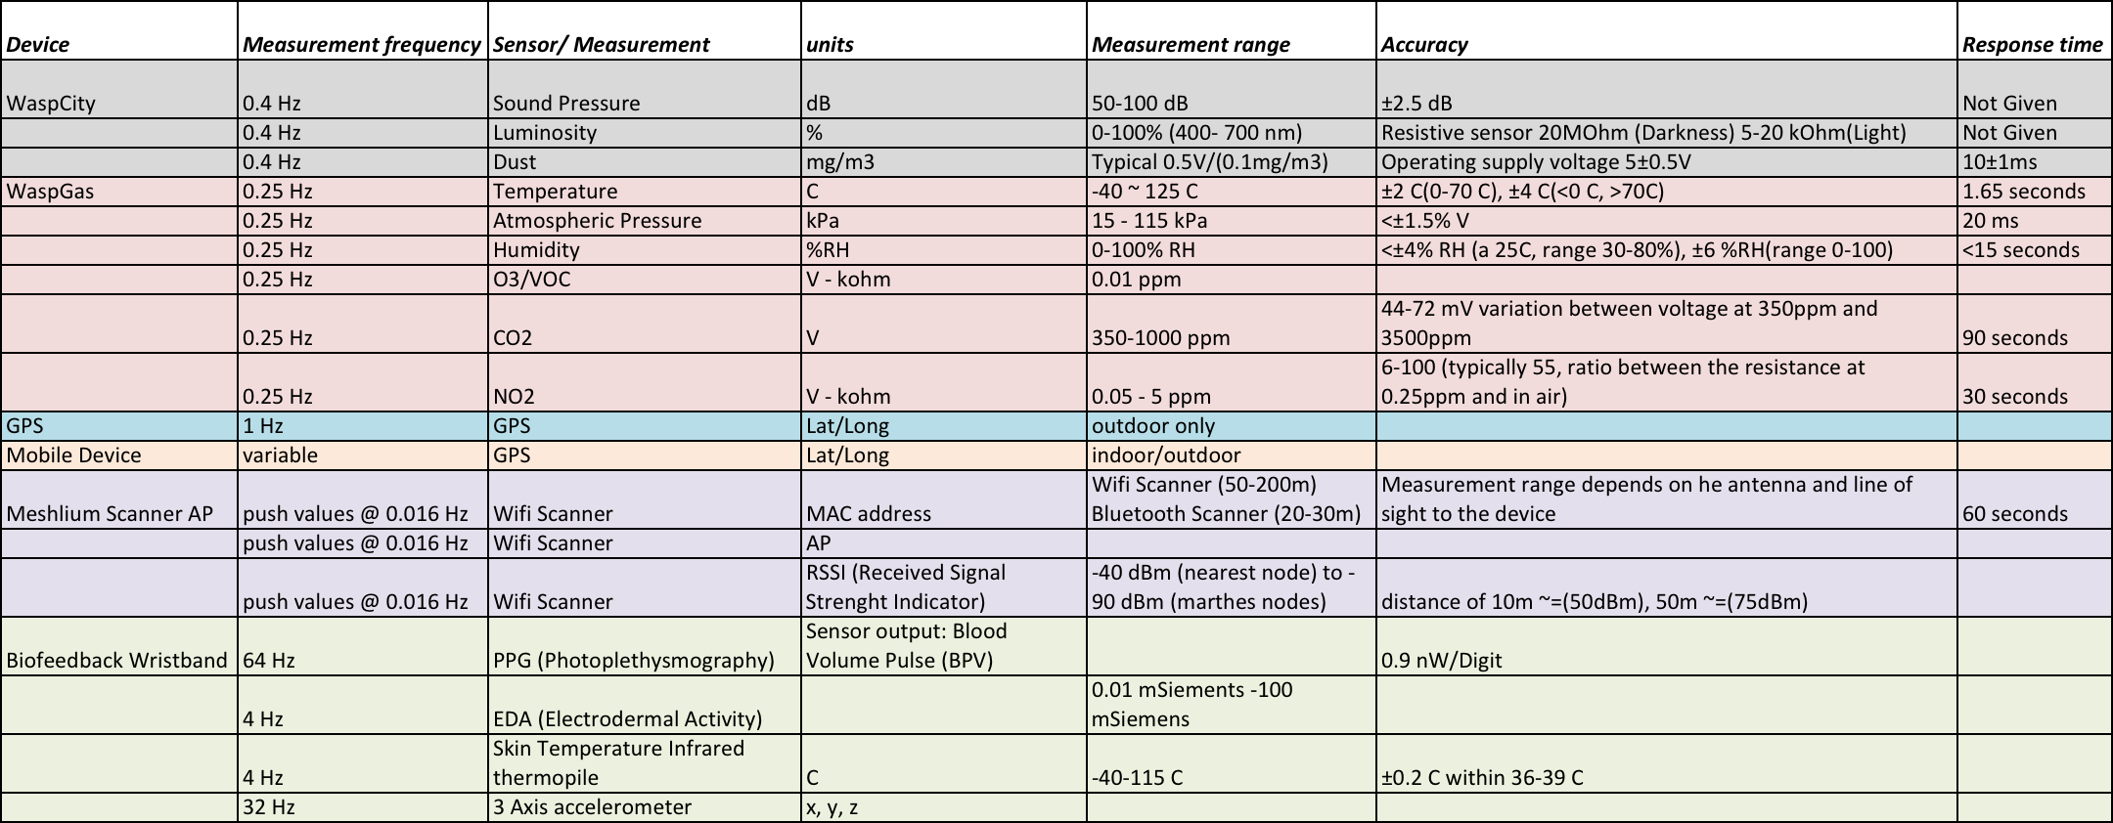

Table 1: Mobile Sensor Equipment Specifications

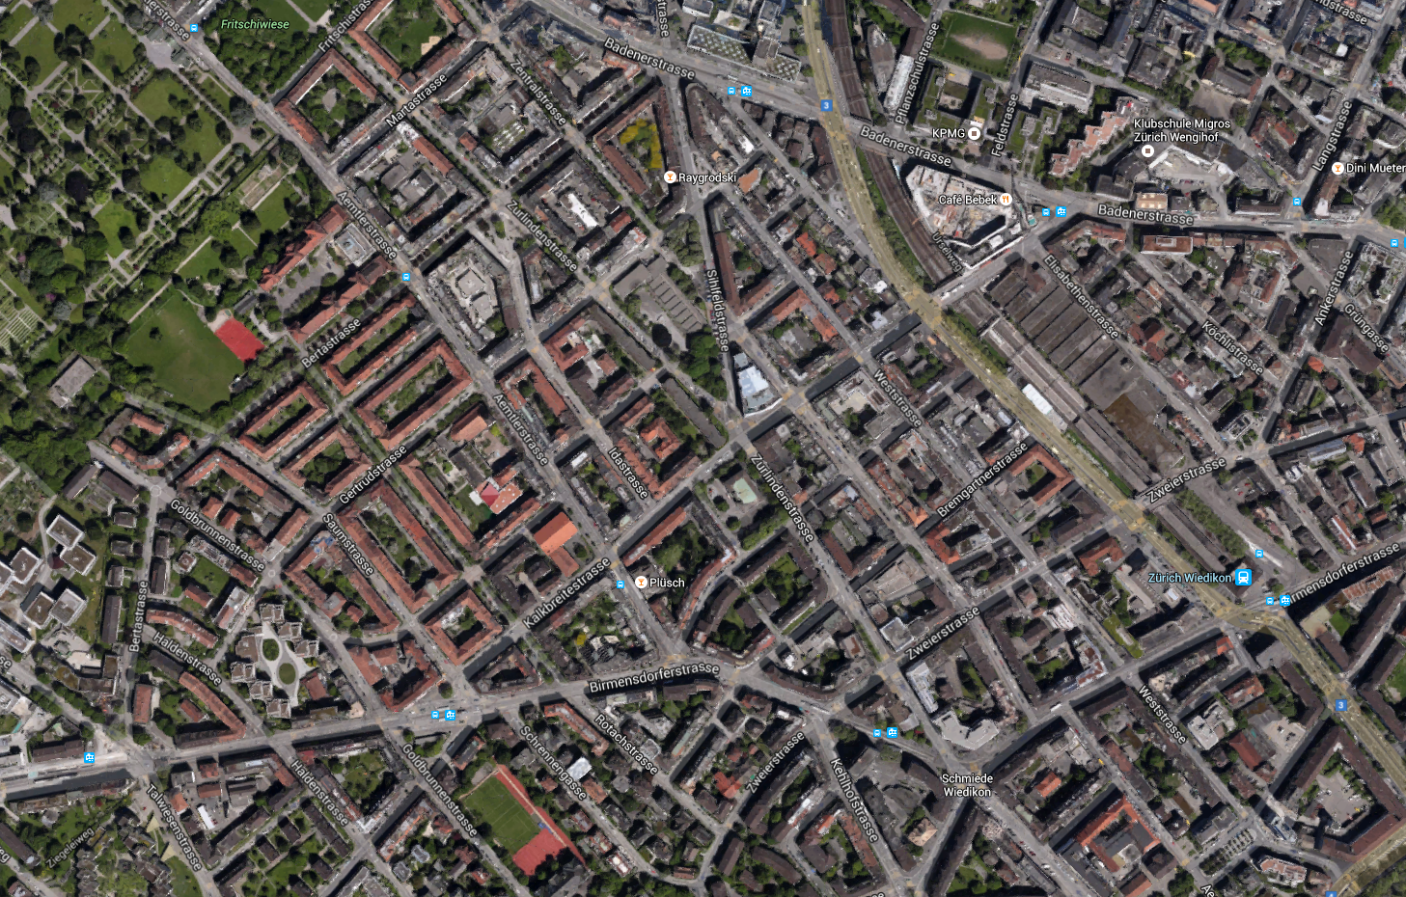

Figure 1: Urban area for participant study